**BACKEND DEVELOPMENT**

**4.4 CREATION OF TABLES**

CREATE TABLE billing (

Customer_ID varchar (11) NOT NULL,

P_ID int (11) NOT NULL,

Date_of_purchase date NOT NULL,

Quantity int (11) NOT NULL,

Price int (11) NOT NULL

);

ALTER TABLE `employee`

ADD PRIMARY KEY (`Emp_ID`);

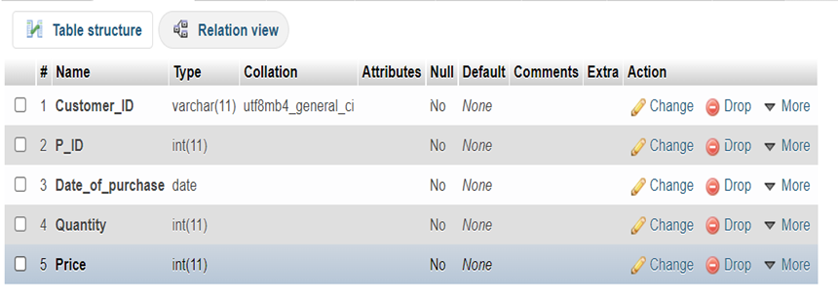

Table 4.3.1: billing

CREATE TABLE employee (

Emp_ID int (4) NOT NULL,

Emp_Name text NOT NULL,

Emp_Address varchar (40) NOT NULL,

DOJ date NOT NULL,

DOB date NOT NULL,

Phone_No int (10) NOT NULL,

Email varchar (20) NOT NULL,

Salary decimal (10,0) NOT NULL

);

ALTER TABLE `product`

ADD PRIMARY KEY (`P_ID`),

ADD KEY `S_ID` (`S_ID`);

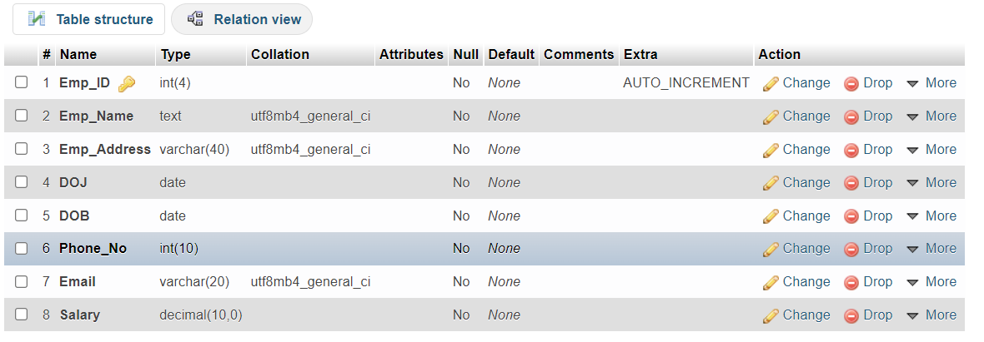

Table 4.3.2: employee

CREATE TABLE product (

P_ID int (10) NOT NULL,

S_ID int (10) FOREIGN KEY (`S_ID`) REFERENCES `supplier` (`S_ID`) ON DELETE CASCADE ON UPDATE CASCADE;

Category text NOT NULL,

P_Type text NOT NULL,

Size_range varchar (10) NOT NULL,

Price int (6) NOT NULL,

Total_qty int (5) NOT NULL

);

ALTER TABLE `product`

ADD CONSTRAINT `S_ID` FOREIGN KEY (`S_ID`) REFERENCES `supplier` (`S_ID`) ON DELETE CASCADE ON UPDATE CASCADE;

COMMIT;

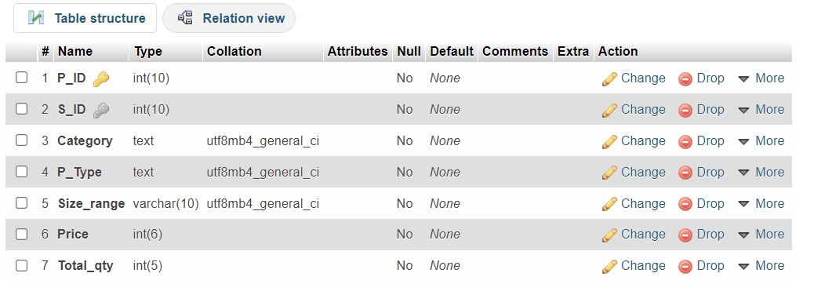

Table 4.3.3: product

CREATE TABLE sale_history (

Year int (11) NOT NULL,

Emp_ID int (11) NOT NULL,

S_ID int (11) NOT NULL,

Profits int (11) NOT NULL

);

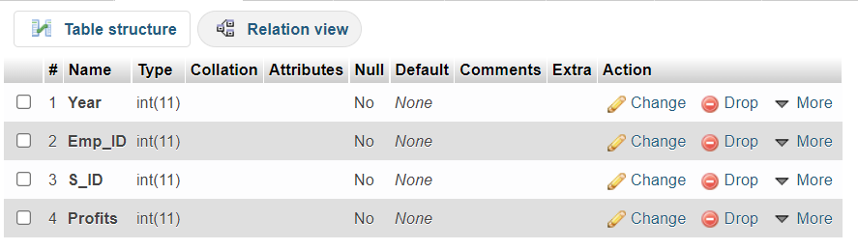

Table 4.3.4: sale_history

CREATE TABLE supplier (

S_ID int (3) NOT NULL,

S_Name text NOT NULL,

S_Address varchar (20) NOT NULL,

S_Phone_No int (10) NOT NULL,

S_Email varchar (40) CHARACTER SET utf8 NOT NULL

);

ALTER TABLE `supplier`

ADD PRIMARY KEY (`S_ID`);

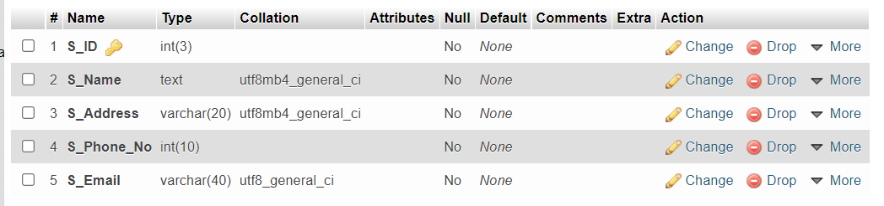

Table 4.3.5: supplier

**TABLES CREATED ARE:**

1. billing
2. employee
3. product
4. sale_history
5. supplier

**4.5 INSERTION OF TUPLES**

**Employee table:**

INSERT INTO `employee` VALUES (`Emp_ID`, `Emp_Name`, `Emp_Address`, `DOJ`, `DOB`, `Phone_No`, `Email`, `Salary`)

(100, 'Aria Monty', 'Rosewood St,Pennsylvania', '2020-02-14', '1995-03-29', 1988776655, 'aria123@gmail.com', '100000'),

(101, 'Hannah Marin', 'Ravenswood St,Pennsylvania', '2019-02-07', '1996-05-27', 1233445566, 'hannah456@gmail.com', '95000'),

(102, 'Caleb Rivers', 'Ravenswood St,Pennsylvania', '2019-02-03', '1995-11-11', 1998800554, 'caleb678@hotmail.com', '110000'),

(103, 'Ezra Fitz', 'Lockswood St,Pennsylvania', '2019-04-01', '1990-06-06', 1004324658, 'mrfitz@hotmail.com', '200000'),

(104, 'Emily Fields', 'Rosewood St, Pennsylvania', '2020-12-10', '1992-01-01', 1348732424, 'emilybakes@gmail.com', '80000'),

(105, 'Alison Dilaurentis', 'Pennhurst,Philadelphia', '2020-01-16', '1995-01-01', 2147483647, 'alidil@gmail.com', '90000');

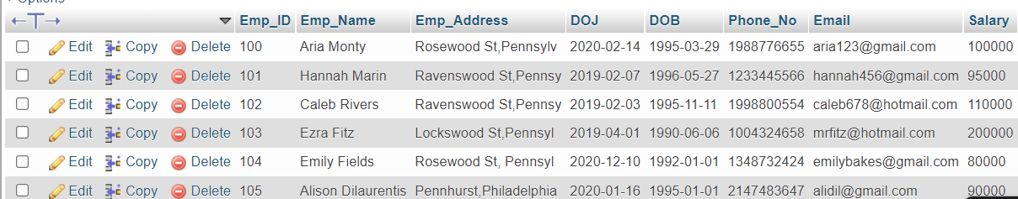

Table 4.4.1

**Billing Table:**

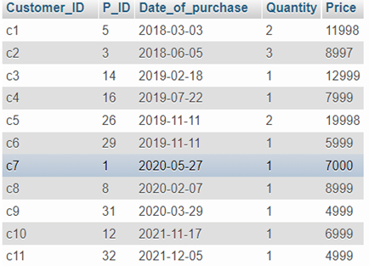

Table 4.4.2

**Product Table:**

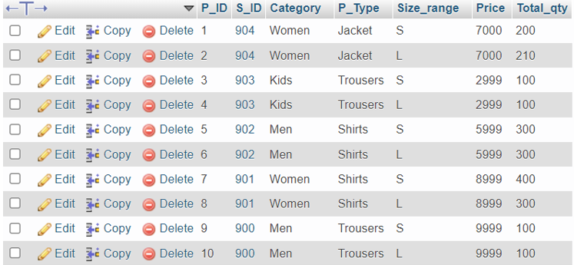

Table 4.4.3

**Sale History Table:**

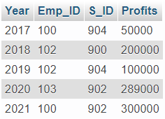

Table 4.4.4

**Supplier Table:**

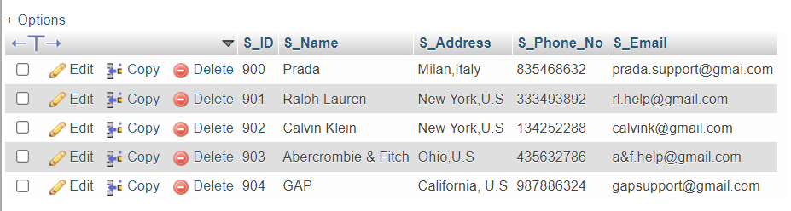

Table 4.4.5

**4.6 TRIGGER**

**4.6.1 TRIGGER NAME-Conversion**

BEGIN

SET NEW.Size_range *

UPPER(NEW.Size_range);

END

*Before:*

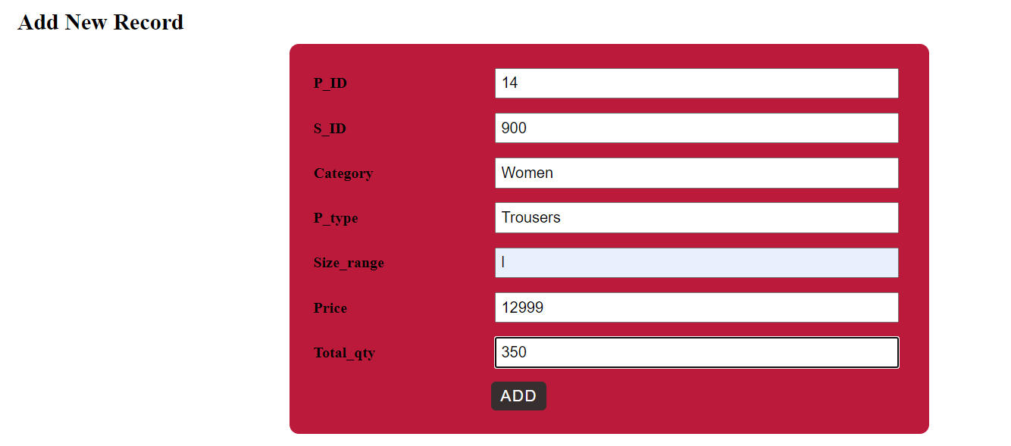

Fig 4.5.1: Before trigger execution

*After:*

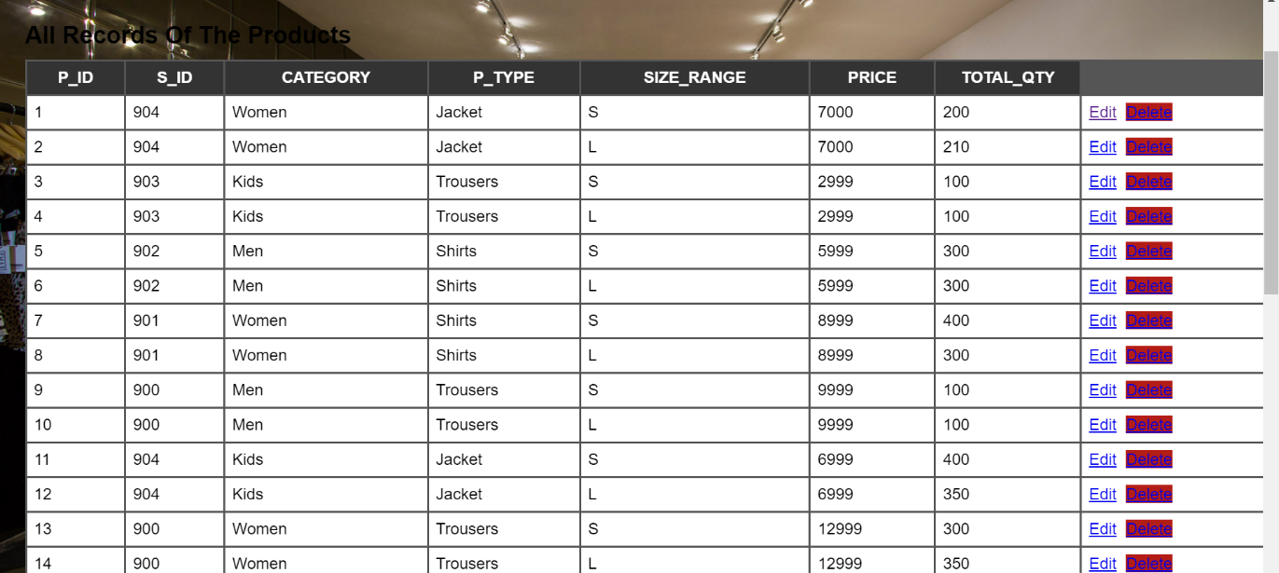

Fig 4.5.2: After trigger execution

**4.6.2 TRIGGER NAME-Final_amt**

BEGIN

SET NEW.Price=NEW.Quantity*NEW.Price);

END

*Before:*

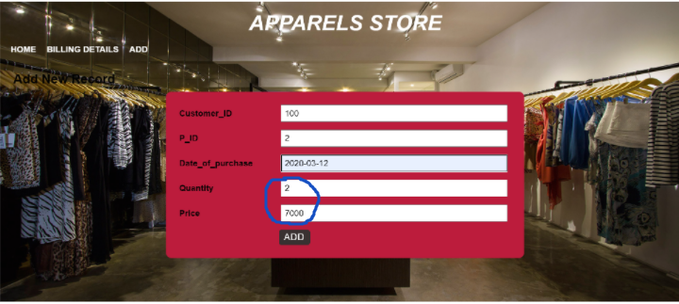

Fig 4.5.3: Before tigger

*After:*

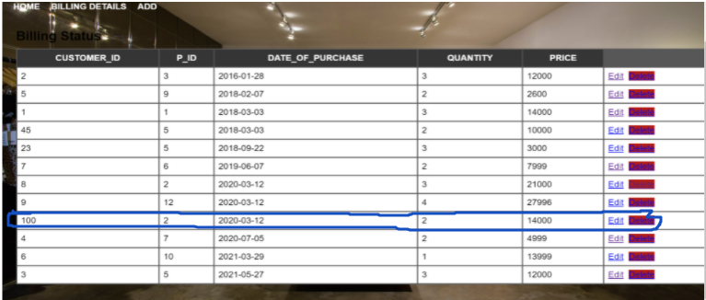

Fig 4.5.4: After trigger

**4.7 CREATION OF STORED PROCEDURES**

CREATE PROCEDURE display_ord_date

BEGIN

SELECT * FROM billing ORDER BY Date_of_purchase;

END

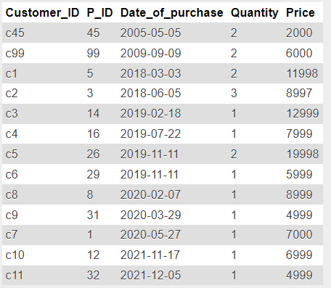

Fig 4.6.1: Stored procedure in backend